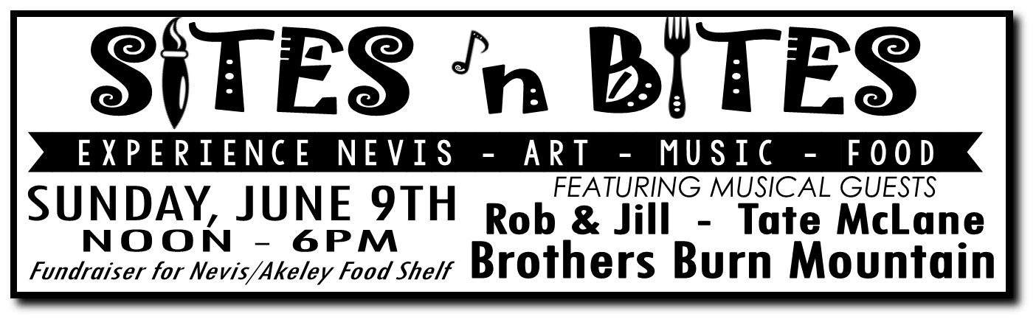
The Nevis C & C is excited to host the 4th annual Sites n’ Bites event again this year. The Nevis Sites n’ Bites event will be June 9, 2019 from noon-6 PM and will help promote what the Nevis area has to offer for Restaurants, retail shops and the arts.
The event will be fun for all ages with food samplings, hands on art projects and crafts for sale, kids games, music and other retail specials. We will have great live music by groups Rob & Jill, Tate McLane, and Brothers Burn Mountain.
We would like you to be a part of this event. Each participating business/artist will be on our “Passport” that the customers will get stamped when they visit your business/booth. When they fill the passport, they will be eligible to win a variety of prizes (donated by our local businesses and artists). Profits from Passport sales will go to the food shelf.
We need your commitment soon, so we can continue preparing. If you are a business not located in town, and would like to set up a booth, there is space in and around the Muskie for food and lots of space for art. It would be ideal if each artist would do either a demonstration or a short workshop (we will create a schedule for these).
Restaurant/Business Name:_______________________________________ Contact #______________
C&C Member (free)___________ Non-member ($40) ___________________________
What you would like to serve: ____________________________________________________________________________________________________________________________________________________________________________________________________

Artist/ Vendor Name: ______________________________________ Contact # ___________________________
C&C Member (free) ________________________ Non-member ($20) __________________________
Your Craft ___________________________________
Demonstration ___________________________ “Create” workshop ____________________________
Thank you for making Nevis a great place to live and visit! Questions, call Tracy 218-252-4222.
Please return form to Tracy at Muskie Waters OR send forms to:
Sites N’ Bites Committee/ Nevis C & C
PO Box 268
Nevis, MN 56467

